Hosted Website link: <https://dheeraj-wall-task.netlify.app/>

**Code :**

* Index.html

<!DOCTYPE html>

<html lang="en">

<head>

    <meta charset="UTF-8">

    <meta http-equiv="X-UA-Compatible" content="IE=edge">

    <meta name="viewport" content="width=device-width, initial-scale=1.0">

    <link rel="stylesheet" href="style.css">

    <title>Wall Task</title>

</head>

<body>

    <h1>Wall Task</h1>

    <section class="container">

        <p class="info">Enter the number of walls and the height of each wall separated by '#' to get the number of walls visible to both persons.</p>

        <form class="wall-form">

            <label for="wall-num">Enter number of walls :</label>

            <input id="wall-num" type="number" value="15">

            <br>

            <label for="wall-heights">Enter the height of each wall starting from the left seperated by '#' :</label>

            <input id="wall-heights" type="text" value="2#4#5#7#12#10#7#9#4#2#1#4#3#1#1">

            <br>

            <div class="form-btn">

                <button class="wall-btn" type="submit">Submit</button>

            </div>

        </form>

    </section>

    <section class="container answer hidden">

        <div class="graphic">

            <img src="img/man-standing-right.png" alt="">

            <div class="bar-graph">

            </div>

            <img src="img/man-standing-left.png" alt="">

        </div>

        <div class="ans-text"></div>

    </section>

    <footer>Made by Dheeraj Kumar Manwani</footer>

    <script src="script.js"></script>

</body>

</html>

* Style.css

:root {

--bg-color: #e9efc0;

--txt-color: #1a120b;

--primary-color1: #4e944f;

--primary-color2: #83bd75;

}

* {

box-sizing: border-box;

padding: 0;

margin: 0;

background-color: var(--bg-color);

color: var(--txt-color);

}

body {

font-size: 1.125rem;

}

h1 {

font-size: 3rem;

text-align: center;

margin: 2rem;

}

input {

text-align: center;

padding: 5px 5px;

border-radius: 5px;

margin: 8px 0;

width: 30%;

}

input[type="number"] {

width: 5%;

}

button {

color: white;

border: #1a120b;

border-radius: 10px;

font-size: 16px;

background-color: var(--primary-color1);

padding: 16px 32px;

width: 250px;

cursor: pointer;

}

button:hover {

background-color: var(--primary-color2);

}

img {

height: 200px;

}

footer {

position: fixed;

bottom: 10px;

width: 100%;

text-align: center;

}

/* Classes */

.container {

width: 60%;

margin: auto;

}

.form-btn {

width: 250px;

margin: auto;

margin-top: 2rem;

}

.graphic {

display: flex;

justify-content: space-between;

max-width: 60rem;

margin: auto;

margin-top: 5rem;

/* background-color: #b4e197; */

}

.bar-graph {

display: flex;

justify-content: space-between;

align-items: baseline;

width: 600px;

}

.bar {

height: 0px;

background-color: var(--primary-color1);

}

.ans-text {

text-align: center;

font-size: 1.5rem;

margin: 2.5rem;

}

/* Utility Classes */

.hidden {

display: none;

}

* Script.js

"use strict";

const maxWallHeight = 14;

let totalWalls,

wallsArr = [];

// Elements

const numWalls = document.querySelector("#wall-num");

const wallStr = document.querySelector("#wall-heights");

const btn = document.querySelector(".wall-btn");

const barGraph = document.querySelector(".bar-graph");

const ansSection = document.querySelector(".answer");

const ansEl = document.querySelector(".ans-text");

// Functions

const showGraphic = (maxHeight) => {

let wallsWidth = 300 / totalWalls;

let wallHeightMultiplier = 200 / maxHeight;

let html = "";

for (let i = 0; i < totalWalls; i++) {

let currHeight = wallHeightMultiplier * Number(wallsArr[i]);

html += `<div class='bar' style="height: ${currHeight}px; width:${wallsWidth}px"></div>`;

}

barGraph.insertAdjacentHTML("beforeend", html);

console.log(wallsArr, totalWalls, wallsWidth);

};

const calcAnswer = (e) => {

e.preventDefault();

ansSection.classList.remove("hidden");

btn.classList.add("hidden");

wallsArr = wallStr.value.split("#");

totalWalls = Number(numWalls.value);

let currMax = -1,

rightAns = 0,

leftAns = 0;

for (let i = 0; i < totalWalls; i++) {

if (Number(wallsArr[i]) > currMax) {

leftAns++;

currMax = Number(wallsArr[i]);

}

}

currMax = -1;

for (let i = totalWalls - 1; i >= 0; i--) {

if (Number(wallsArr[i]) > currMax) {

rightAns++;

currMax = Number(wallsArr[i]);

}

}

showGraphic(currMax);

const html = ` <h3>Left Person can see ${leftAns} walls & Right Person can see ${rightAns} walls</h3>`;

ansEl.insertAdjacentHTML("afterbegin", html);

};

// event listeners

btn.addEventListener("click", calcAnswer);

**Screenshots:**

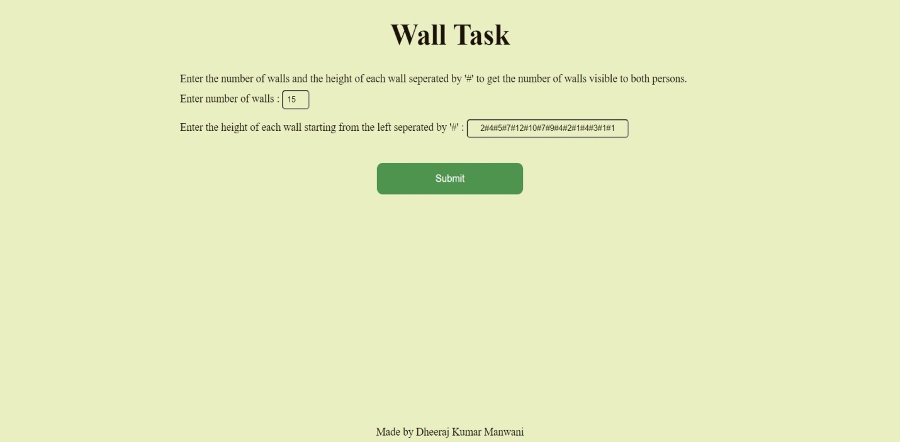

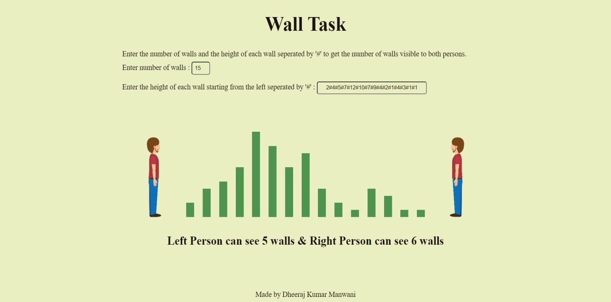

**Explanation:**

* Used querySelector() to read input values on pressing the submit button.
* Added event listener on button to trigger calcAnswer function.
* Used split() method to extract wall heights from the entered string and store them in an array.
* Looped through the array twice to calculate the number of visible walls from both sides.
* Inserted the answer text and bar graph using insertAdjacentHTML() on clicking submit.
* Removed hidden class (having display:none) from the answer container to show the answer on clicking the submit button
* I have also addressed the two edge cases
  1. Total number of walls not equal to number of wall heights given
  2. Wall height string not present in correct format i.e., number#number#number…